Task 1: Auto-Complete a Python Class for Bank Account
Task Description #1
• Write a class definition comment and start the constructor for a class called BankAccount with
account_holder and balance attributes. Use GitHub Copilot to auto-complete the rest of the
class, including methods to deposit, withdraw, and display balance.
Week2 -
Thursday
Expected Output #1
• Complete class with methods like:
deposit(self, amount)
withdraw(self, amount)
display_balance(self)
• Output from sample usage:
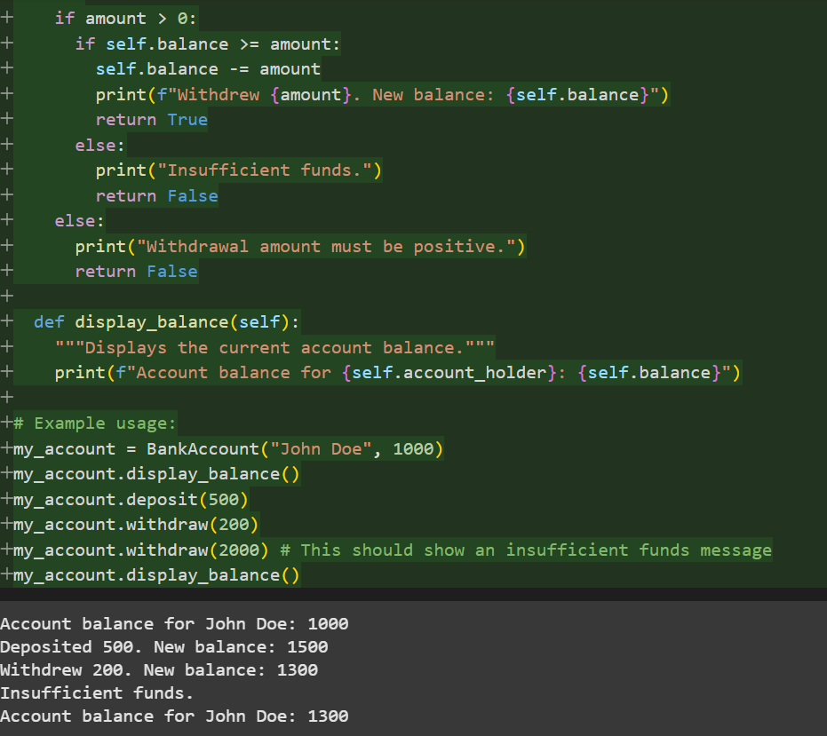
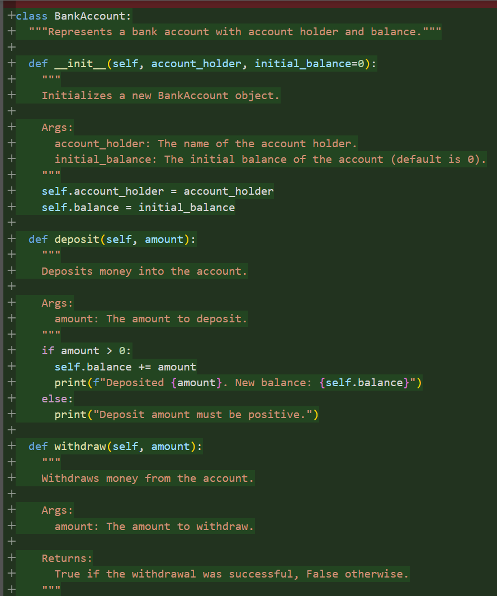
Code and Output:

Observation: In this code we can observe that it gives Multiple outputs like account balance, deposite and new balance after deposite , withdraw and new balance after withdraw and lastly it shows the insufficient funds too if we enter more withdraw amount than our balance .

Task 2: Auto-Complete a For Loop to Sum Even Numbers in a List
Task Description #2
• Write a comment and the initial line of a loop to iterate over a list. Allow GitHub Copilot to
complete the logic to sum all even numbers in the list.
Expected Output #2
• Code that:
• Iterates over a list
• Checks if the number is even using % 2 == 0
• Accumulates the sum
• Sample input/output:
Code and Output:
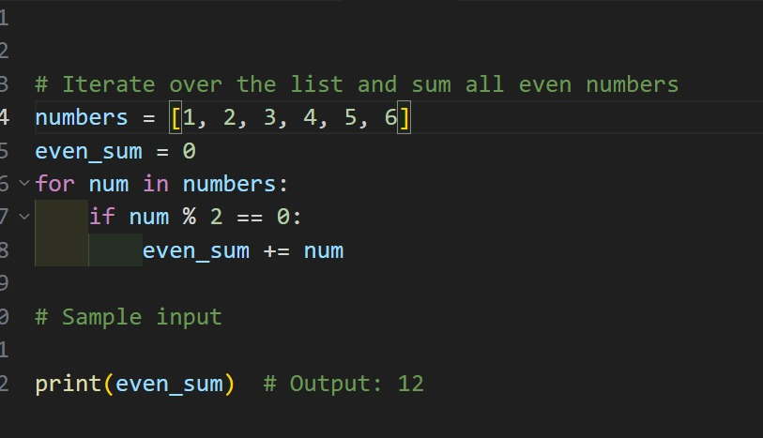
Output;
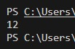
Observation: In this we can observe that the code is autogenerated by the github copilot and it gave the full code by itself.

Task 3: Auto-Complete Conditional Logic to Check Age Group
Task Description #3
• Start a function that takes age as input and returns whether the person is a child, teenager,
adult, or senior using if-elif-else. Use Copilot to complete the conditionals.
Expected Output #3
• Function like:
Output for age_group(45) ➝ "Adult"
Code & Output:
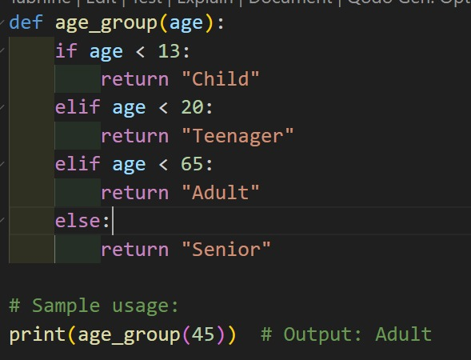
Output:
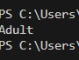
Observation: In this code we can observe that the code is generated by the github copilot and after giving the initial line it created the full code as we wanted .

Task 4: Auto-Complete a While Loop to Reverse Digits of a Number
Task Description #4
• Write a comment and start a while loop to reverse the digits of a number. Let Copilot
complete the loop logic.
Expected Output #4
• Functional loop: Output: 4321
Code and Output;
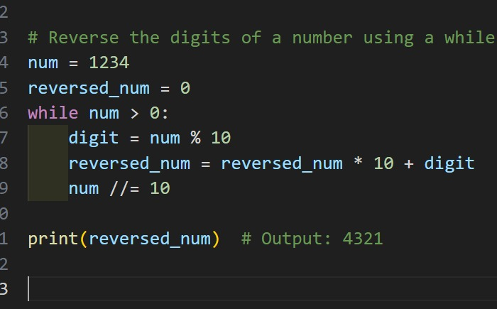
Output:
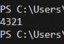
Observation: In this We can Observe that the vs code githut copilot auto generated the full code by entering the initial line of the code and gave the output we wanted

ask 5: Auto-Complete Class with Inheritance (Employee → Manager)
Task Description #5
• Begin a class Employee with attributes name and salary. Then, start a derived class Manager
that inherits from Employee and adds department. Let GitHub Copilot complete the methods
and constructor chaining.
Expected Output #5
• Auto-generated code like:
Name: John, Salary: 50000, Dept: IT
Code and Output;
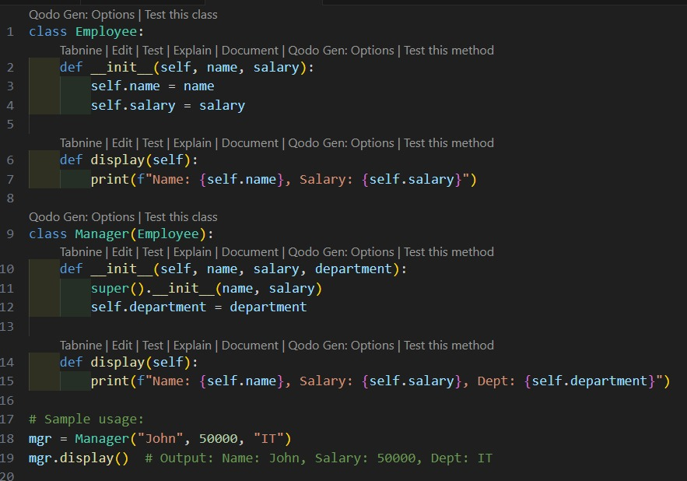
Output:
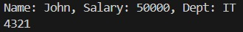

Observation: In this we can Observe that the vs code github copilot generated the code after we typed the comment for what code we want.

